Hypotonic | Hypertonic
Isotonic | Hydrophilic Head
Hydrophobic Tail | Phospholipid
Lipid Bilayer | Transport Protein
Carbohydrate Chain | Phospholipids

Active Transport | Passive Transport
Exocytosis | Endocytosis
Diffusion | Facilitative Diffusion
Osmosis | Movement of small particles from high to low until equilibrium is reached  (spread out)
Diffusion involving water | Diffusion with the use of a “helper” protein

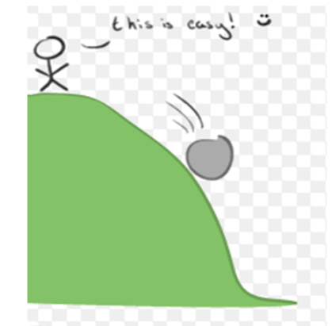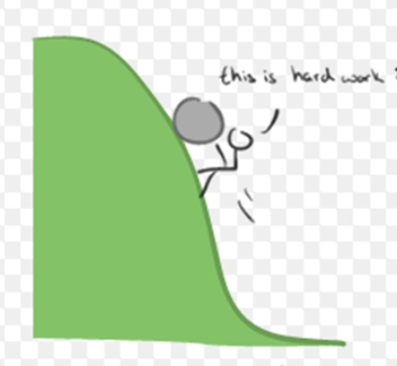
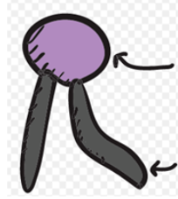
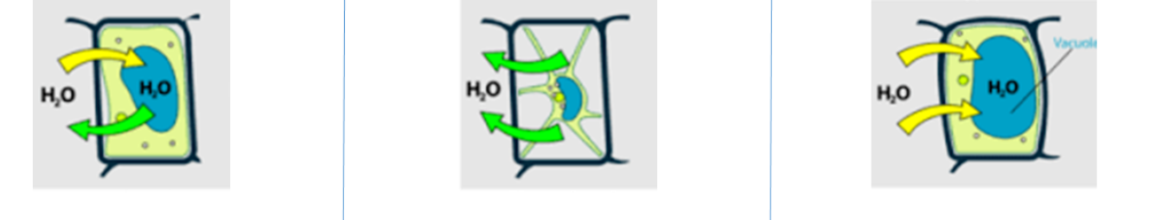

High to Low.  No Energy | Low to High.  Uses Energy
Cell Transport | Movement of materials in and out of the cell
Moves large molecules into a cell.  Uses energy | Moves large molecules out of a cell  Uses energy
Water moves in and out of a cell.  Cell does not change in size | Water goes outside the cell.  Cell shrinks.
Water goes into the cell.  The cell gets big | With the Gradient

With the gradient | Water loving
Water fearing

